ASA Plunging Championship
Winners

T H Clarke
Torpedo SC
Winner 1883

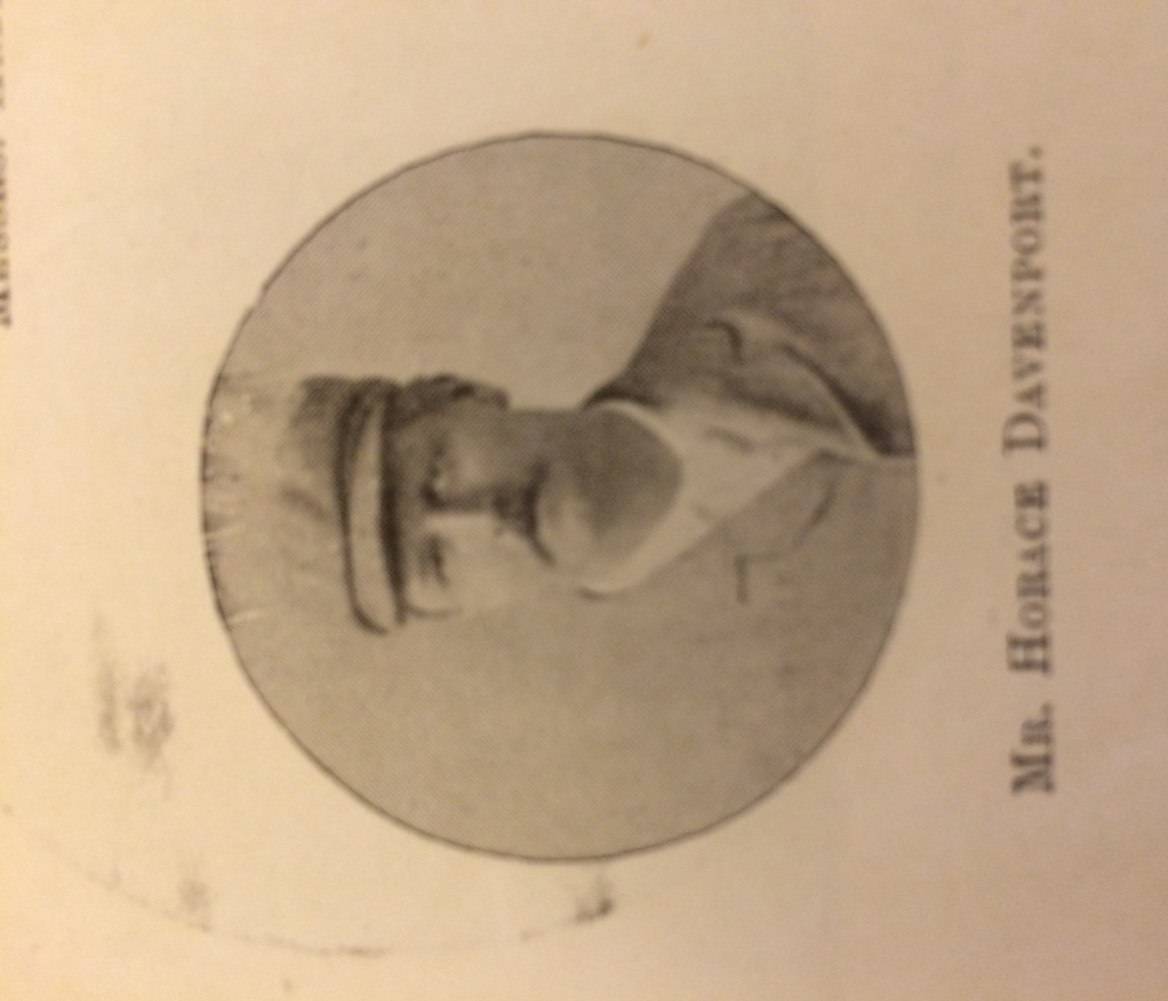
Horace Davenport
Ilex SC
Winner 1884 1885 1886

G A Blake
Lewisham SC
Winner 1887 1888 1889 1890 1891

H A Wilson
Woodside SC
Winner 1892
S T Dadd
Lewisham SC
Winner 1892

J McHugh
Edge Lane SC
Winner 1894

W Taylor
Bootle SC
Winner 1895 1898 1899 1900 1901 1903 1905 1906

W Allason
Otter SC
Winner 1896 1897 1902 1907 1908

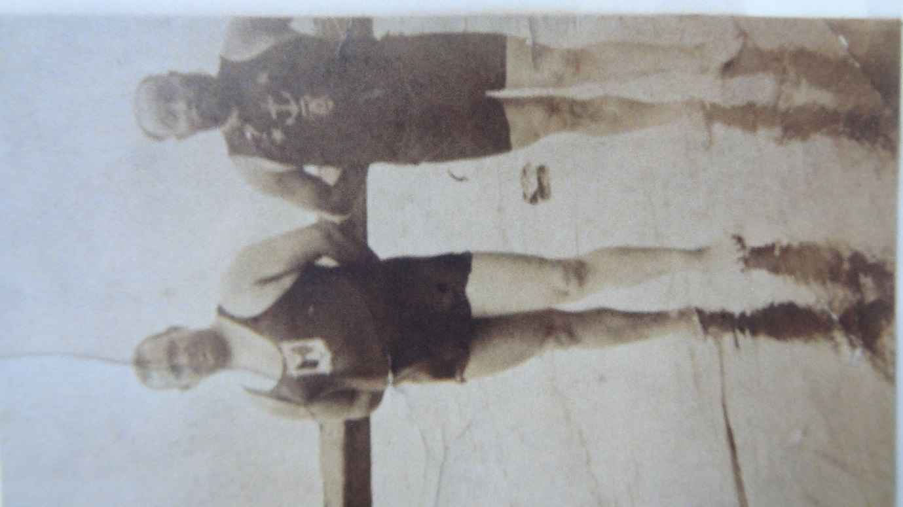
John Arthur ‘Jack’ Jarvis
Leicester SC
Winner 1904

