ASA Long Distance championship
Winners

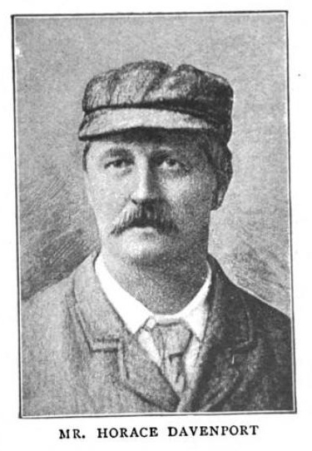
Horace Davenport
Ilex SC
29.5.1850-22.1.1925

Winner 1877 1878 1879

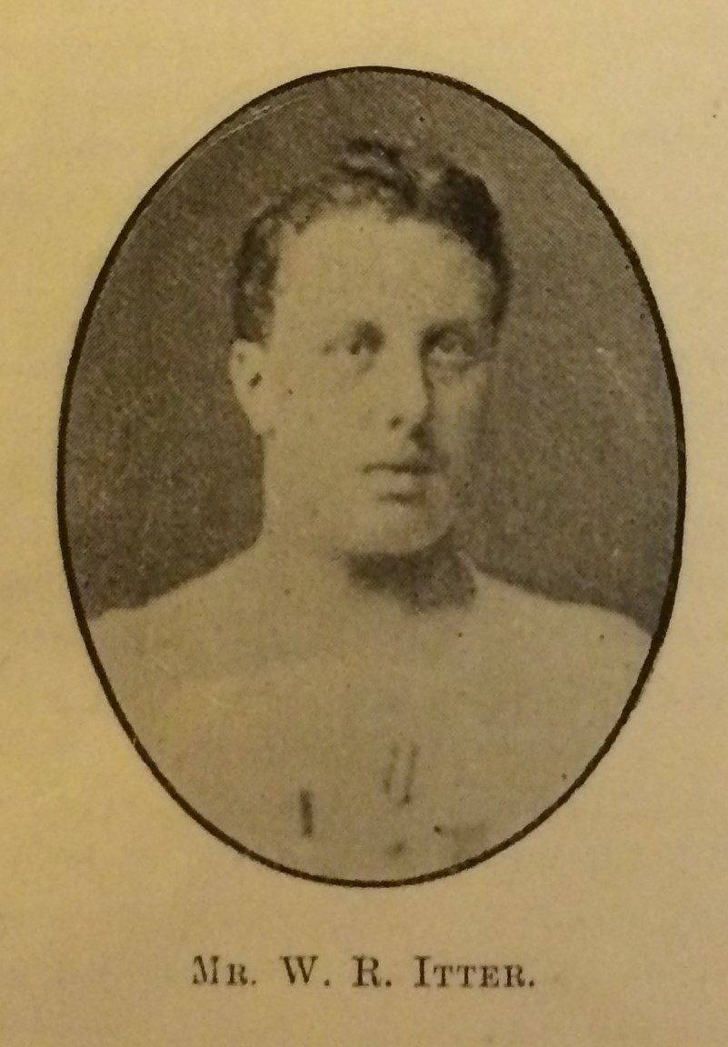

William Robert Itter
Regent SC
1859-19.6.1931

Winner 1880 1883

W. R. Richardson
Dublin

Winner 1881

F.W. Huntington
Liverpool SC

Winner 1882

G. Bell
Unity SC

Winner 1884 1885

Alfred Edward France
Neptune SC
1860-1916

Winner 1886 1887

H. Bowden
Polytechnic SC

Winner 1889

William Henry
Zephyr SC
29.6.1859-20.3.1928

Winner 1890

A Ibbott
Dreadnought SC

Winner 1891

Matthew Drake
City of London Police SC
1867-?1915

Winner 1892

John Henry ‘Jack’ Tyers
Manchester Osborne SC
1878-17.5.1932
Prof swimmer/bath attendant
Winner 1893 1894

W. Green
Liverpool SC
Winner 1896

Percival Frederick ‘Percy ‘ Cavill
East Sydney SC
1875-1940

Winner 1897

John Arthur ‘Jack ‘ Jarvis

Leicester SC
24.2.1872-9.5.1933 swimming teacher
Winner 1898 1899 1900 1901 1902 1903 1904 1906

David Billington
Bacup SC
1886-4.2.55 baths manager
Winner 1905

Paul Radmilovic
Weston super Mare SC
5.3.1886 - 29.9.1968 hotelier
Winner 1907

Frank Walter Springfield
Brisbane , Queensland
22.8.1887-9.7.1958

