ASA Ladies 100y championship

Hilda Charlotte Thorp
Leeds SC
1884-
Mrs Pickles
Winner 1901 1903

Maggie Scott
Bacup SC
Winner 1902 1905

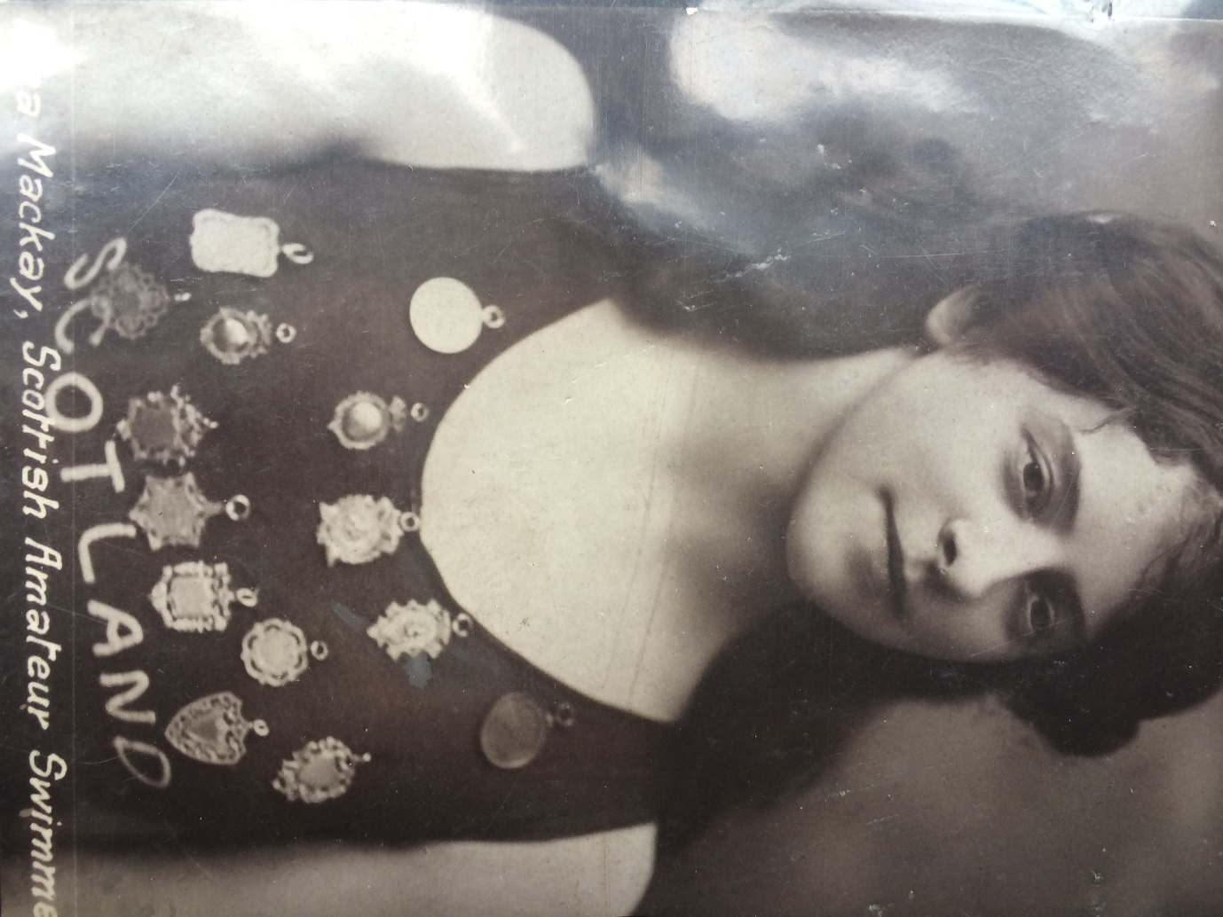
H. Mackay
Fairfield SC Scotland
Winner 1904
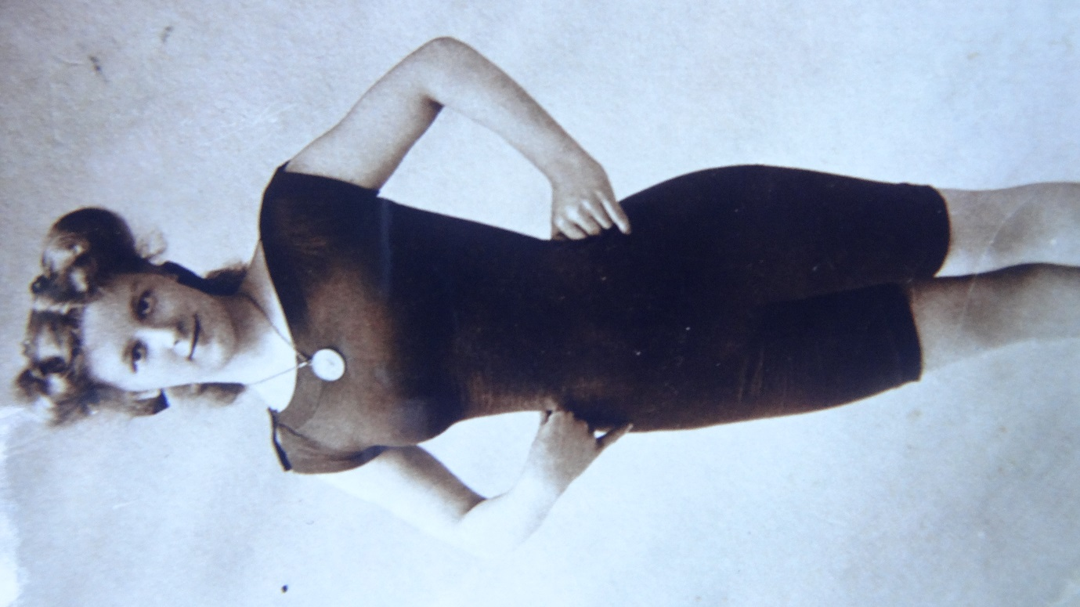

Jennie Fletcher
Leicester SC
19.3.1890- 1968
Mrs Hyslop
Winner 1906 1907 1908

