ASA 500y championship

Winners

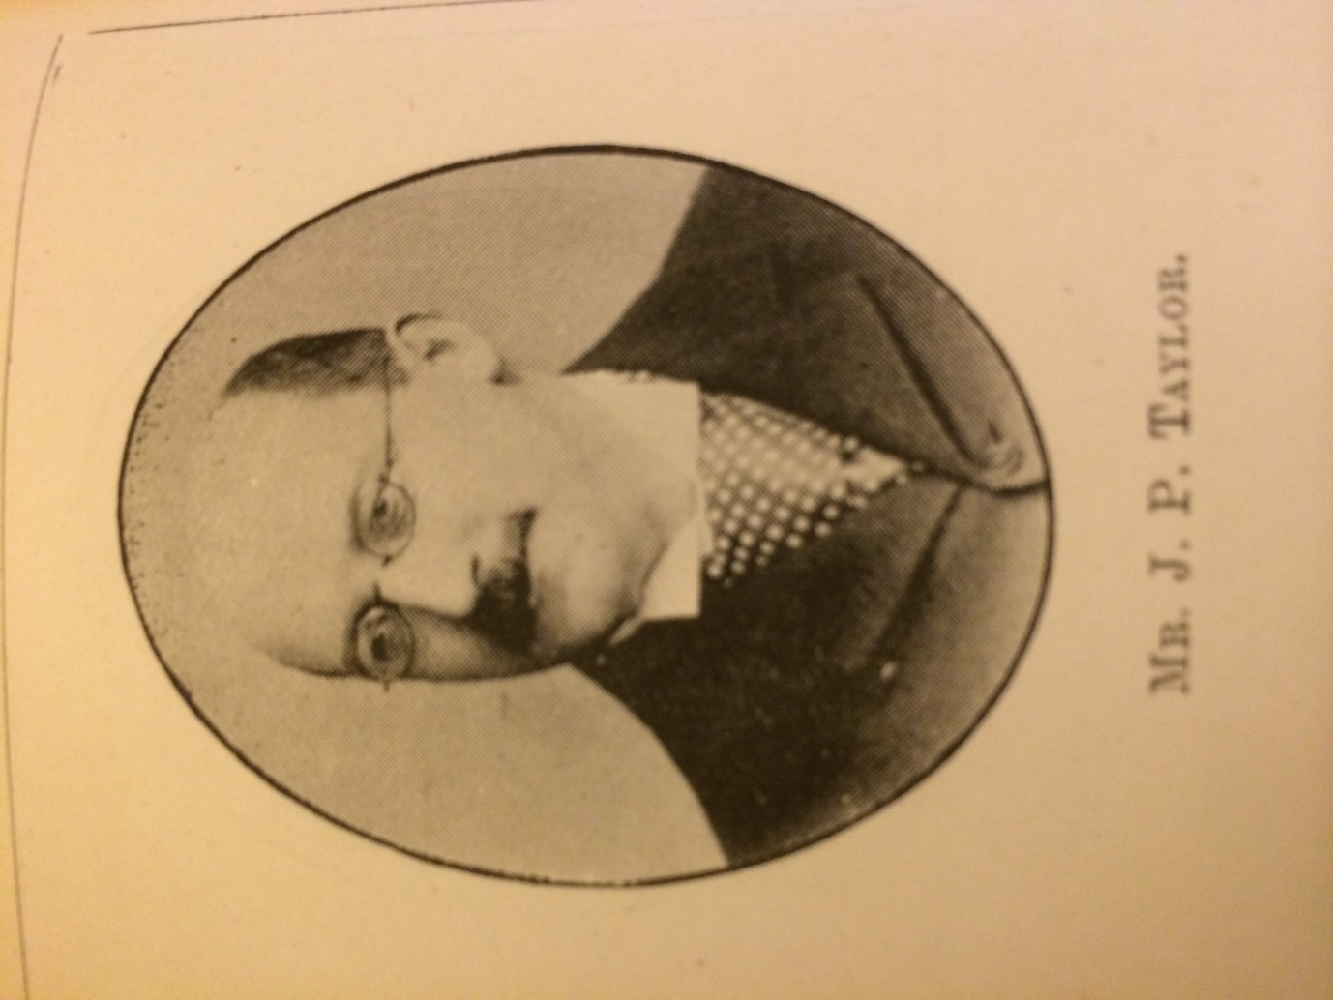
James P Taylor
Newcastle SC
1850-1932

Winner 1878

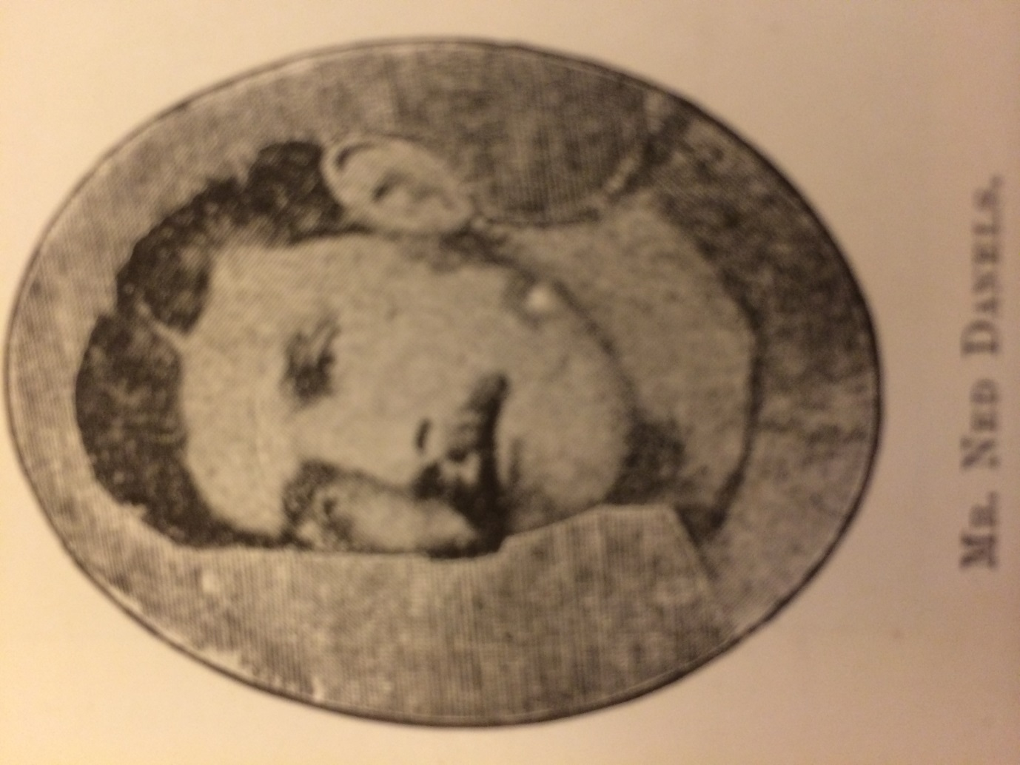

Edmund Carter ‘Ned’ Danels
North London SC
July 1857-April 1885
Winner 1879 1880 1881 1882 1883

Thomas 'Tom' Cairns
Everton SC
1863-bath attendant
Winner 1884 1885

Joseph 'Joey' Nuttall
Stalybridge SC
31.8.1869-1 .6.1942 later prof swimmer

Winner 1886 1887 1888

James F. Standring
Zephyr SC
1865-1934

Winner 1889

William Evans
Manchester Swan SC

Winner 1890 1891 1892

Jack Henry ‘Jack’ Tyers
Manchester Osborne SC
1878-17.5.1932
Professional swimmer/bath attendant

Winner 1893 1894 1895 1896

John Henry ‘Rob’ Derbyshire
Manchester Osborne SC
29.11.1878-30.7.1938
Baths Manager

Winner 1897

John Arthur ‘Jack’ Jarvis
Leicester SC
24.2.1872-9.5.1933
Swimming teacher

Winner 1898 1899 1900 1901

David Billington
Bacup SC
1886-4.2.55
Baths manager

Winner 1902 1903

(Charles) Eric Forsyth
Hyde Seal SC
10.1.1885-24.2.1951

Winner 1904

Bernard Bede 'Barney' Kiernan
Australia
1886-1905

Winner 1905

Henry Taylor
Chadderton SC
17.3.1885-28.2.51
Bath attendant

Winner 1906 1907 1908

