**ASA 440y salt water championship**

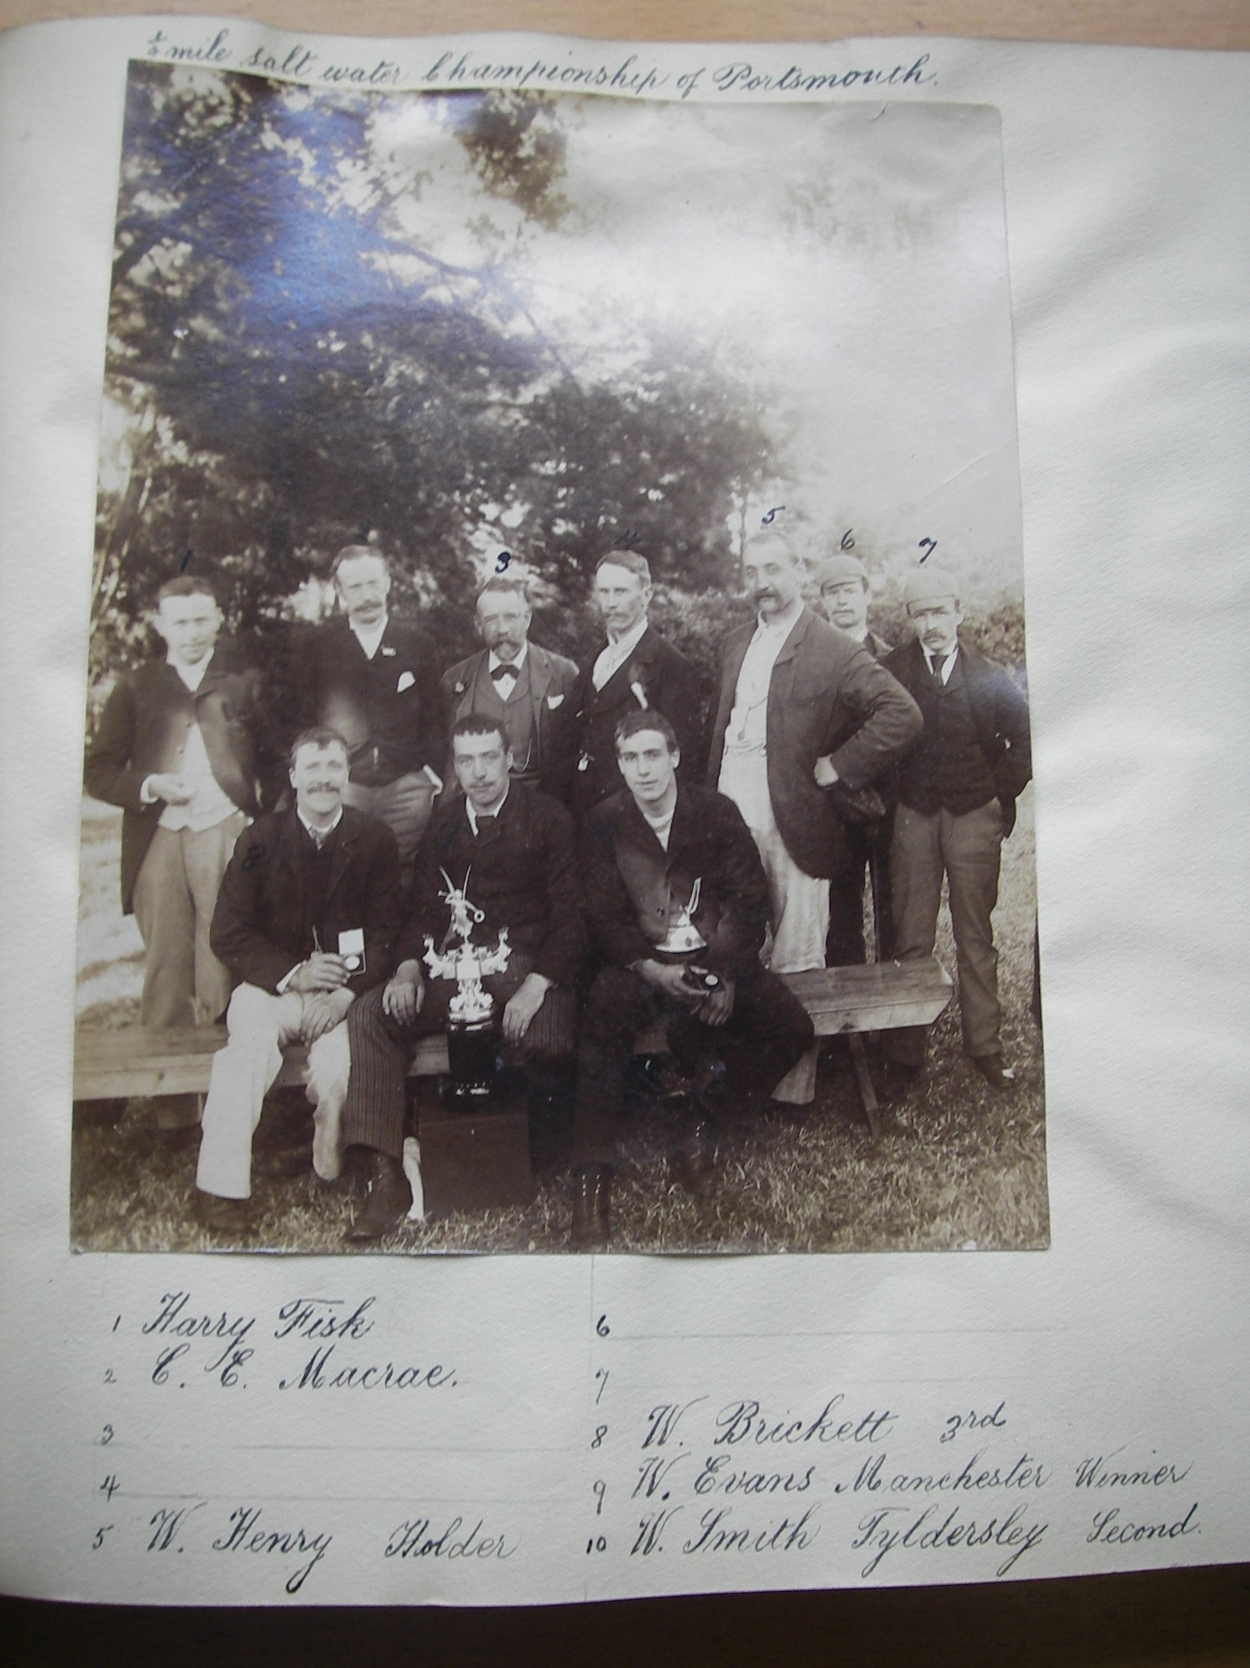

Thomas ‘Tom’ Cairns’

Everton SC

1863-bath attendant

Winner 1884

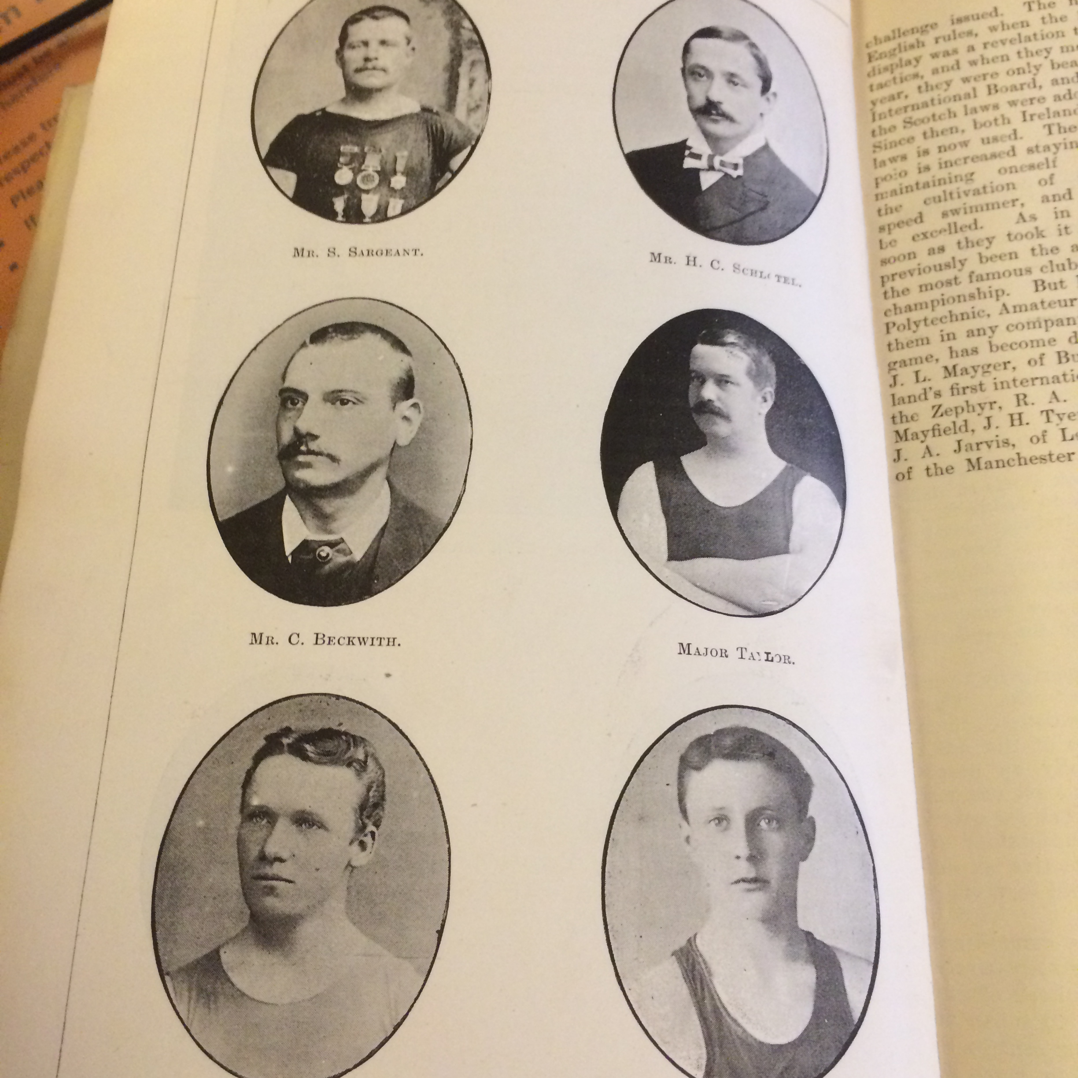

|  |
| --- |
| Herbert C. Schotel |
| Surbiton SC |
| 1866-  Winner 1885 1886 1887     |  | | --- | | Joseph 'Joey' Nuttall | | Stalybridge SC | | 31.8.1869-1 .6.1942 later prof swimmer  Winner 1888    William Henry  Zephyr SC  29.6.1859 - 20.3.1928  Winner 1889     |  | | --- | | William Evans | | Manchester Swan SC  Winner 1890 1891 1892    John Henry ‘Jack’ Tyers  Manchester Osborne SC  1878-17.5.1932  Professional swimmer/bath attendant  Winner 1893 1894 1895 1896     |  | | --- | | Percy Cavill | | Sydney NSW Australia  1875-1940  Winner 1897     |  | | --- | | John Arthur 'Jack' Jarvis | | Leicester SC | | 24.2.1872-9.5.1933 swimming teacher  Winner 1898 1890     |  | | --- | | Frederick Claude Vivian 'Freddie' Lane | | East Sydney SC | | 2.2.1880-19.5.1969 printer  Winner 1899     |  | | --- | | David Billington | | Bacup SC | | 1886-4.2.55  Baths manager  Winner 1901 1903 1904  Richard ‘Dick’ Theophilus Cavill  Sydney Otter SC  1884-1938  Winner 1902     |  | | --- | | Bernard Bede 'Barney' Kiernan | | Australia | | 1886-1905  Winner 1905     |  | | --- | | Henry Taylor | | Chadderton SC | | 17.3.1885-28.2.51  Bath attendant  Winner 1906 1907     |  | | --- | | Francis Joseph Edmund 'Frank' Beaurepaire | | Melbourne SC | | 13.5.1891-29.5.1956  Winner 1908 | | | | |  | | | | | | |
|  |
|  |