ASA 220 yard championship

Winners

Edmund Carter ‘Ned’ Danels
North London SC
July 1857-April 1885
Winner 1880 1881 1882

Thomas ‘Tom’ Cairns’
Everton SC
1863-bath attendant
Winner 1883 1884 1885

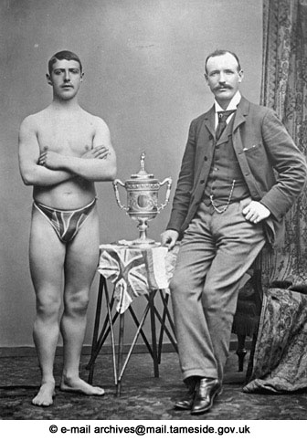

Joseph 'Joey' Nuttall
Stalybridge SC
31.8.1869-1 .6.1942 later professional
Winner 1886 1887 1888

E. T. Jones
Manchester Swan SC
Winner 1889

William Evans
Manchester Swan SC
Winner 1990 1991

John Henry Tyers
Manchester Osborne SC
1878-17.5.1932 prof swimmer/bath attendant-Farnworth SC in 1997
Winner 1992 1993 1994 1995 1996 1997

John Henry 'Rob' Derbyshire
Manchester Osborne SC
29.11.1878 - 30.7.1938 Baths manager
Winner 1998 1900 1901 1903

Frederick Claude Vivian 'Freddie' Lane ( Australia)
East Sydney
2.2.1880-19.5.1969 printer
Winner 1902

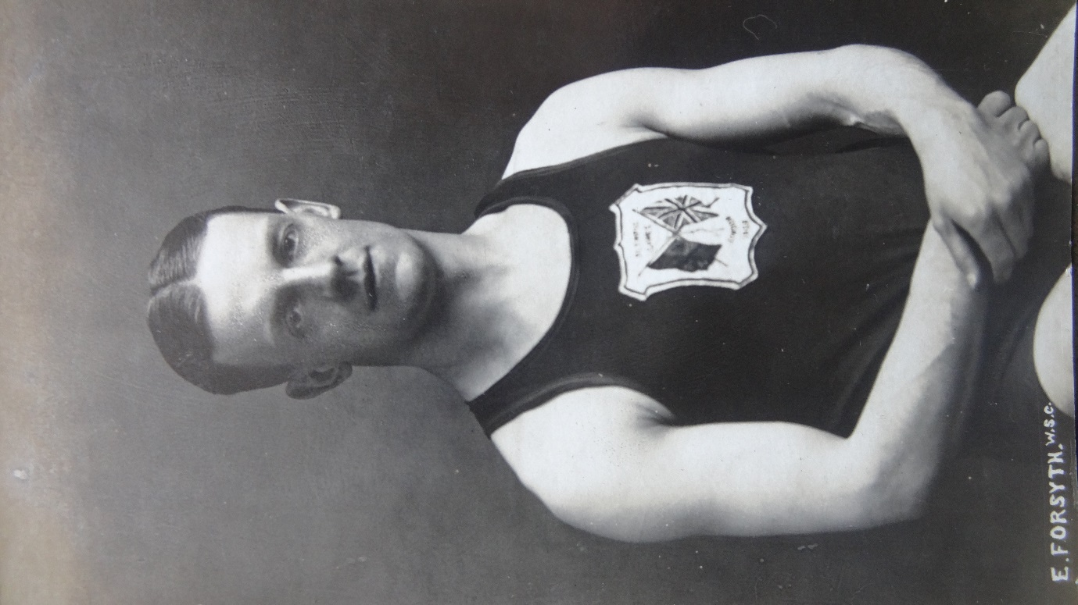
(Charles) Eric Forsyth
Hyde Seal SC
10.1.1885-24.2.1951
Winner 1904

Bernard Bede 'Barney' Kiernan
Australia
1886-1905
Winner 1905

Cecil Healey
Australia
28.11.1881-29.8.1918
Winner 1906

Zoltan de Halmay
Hungary
18.6.1881-20.5.1956 coach/trainer
Winner 1907

F. E. 'Frank' Beaurepaire
Melbourne SC
13.5.1891-29.5.1956
Winner 1908

