ASA 1 mile championship
Winners

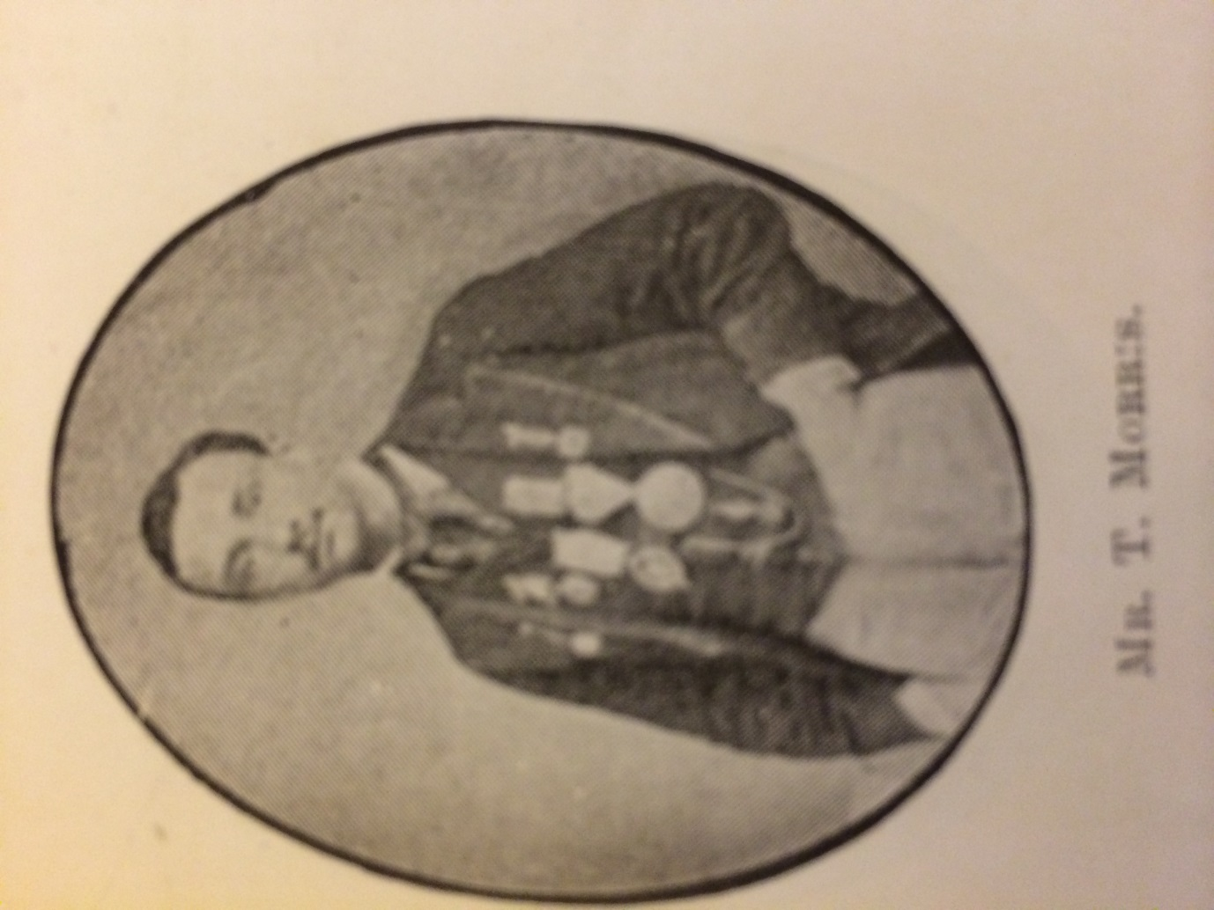
Tom Morris
National SC

Winner 1869

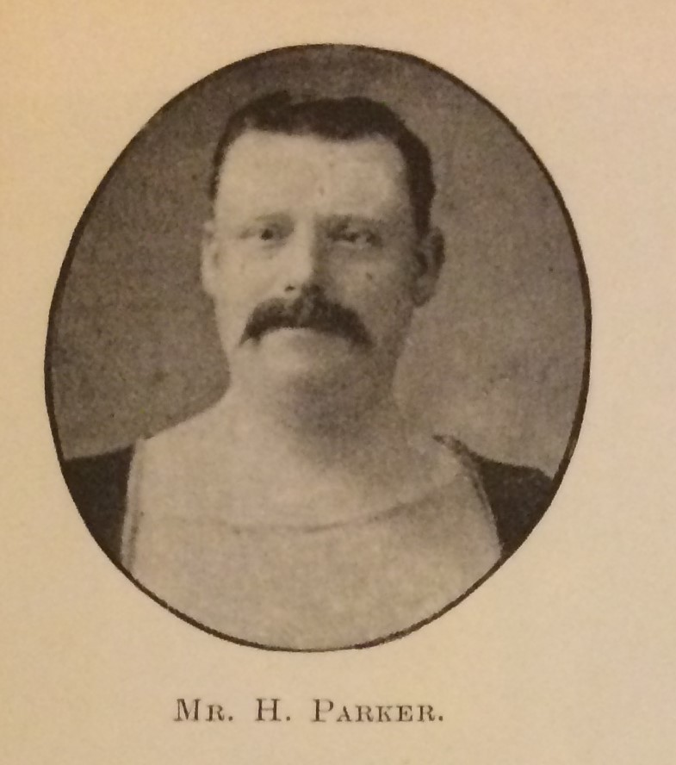
Harry Parker
Alliance SC

Winner 1870 1871 1872

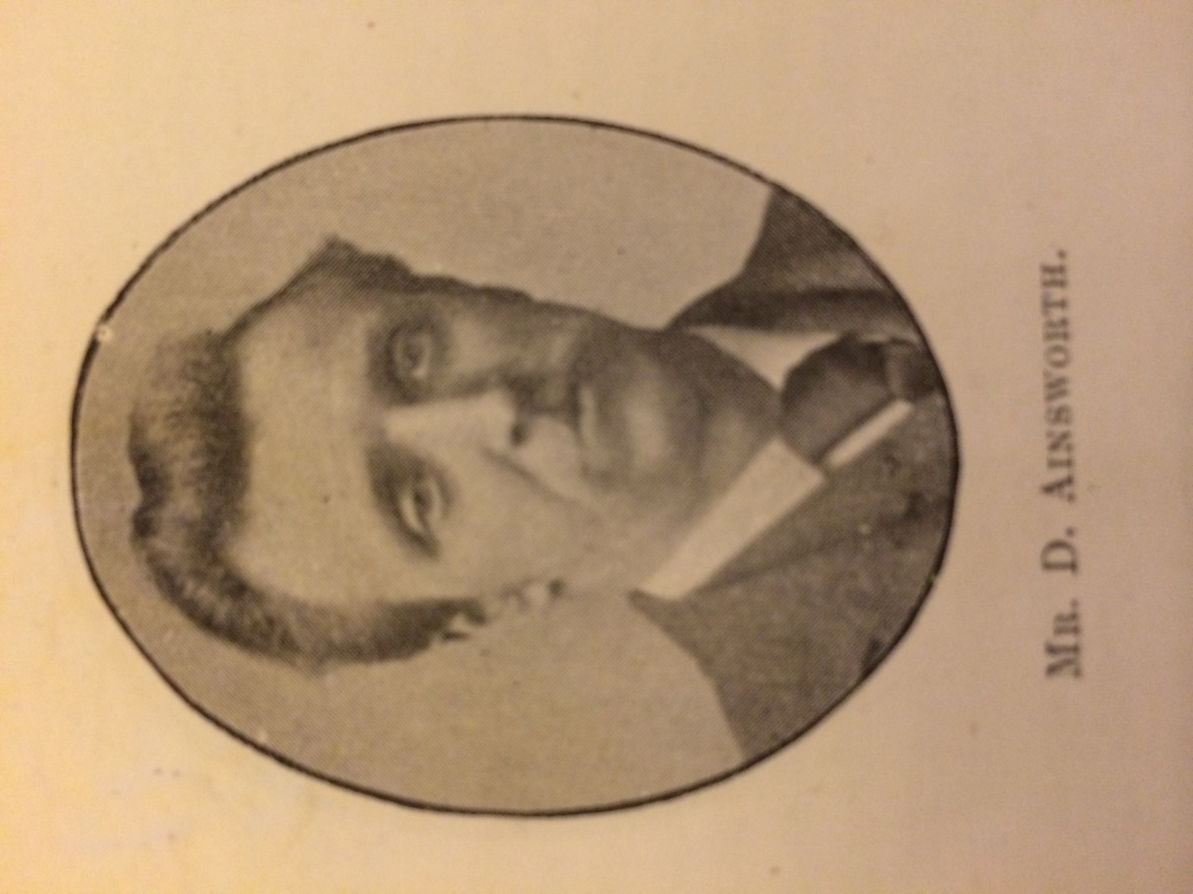
David 'Dave' Ainsworth
Alliance SC
1852-20.6.1939

Winner 1873

Horace Davenport
Ilex SC
29.5.1850-22.1.1925

Winner 1874 1875 1876 1877 1878 1879

James P Taylor
Newcastle SC
1850-1932

Winner 1880 1881 1882

Edmund Carter ‘Ned’ Danels
North London SC
July 1857-April 1885

Winner 1883

G. Bell
Sandringham SC

Winner 1884

Samuel Sargeant
Portsmouth SC
1860-1937

Winner 1885

Herbert C Schotel
Surbiton SC
1866-

Winner 1886

Joseph ‘Noel’ Nuttall
Stalybridge SC
31.8.1869-1.6.1942
Later professional swimmer

Winner 1887

James F. Standring
Zephyr SC
1865-1934

Winner 1888

H. Bowden
Polytechnic SC

Winner 1889

Samuel Wilson 'Sam' Greasley
Leicester SC
1868 -1945 later prof swimmer/boot worker

Winner 1890 1891 1892

John Henry ‘Jack’ Tyers
Manchester Osborne SC
1878-17.5.1932
Professional swimmer later bath attendant

Winner 1893 1894 1895 1896

John Arthur ‘Jack’ Jarvis
Leicester SC
24.2.1872-9.5.1933
Swimming teacher

Winner 1897 1898 1899 1900 1901 1902

David Billington
Bacup SC
1886-4.2.55 baths manager

Winner 1903 1904 1905

Henry Taylor
Chadderton SC
17.3.1885-28.2.1951
Bath attendant

Winner 1906 1907

Francis Edmund ‘Frank’ Beaurepaire
Melbourne SC
13.5.1891-29.5.1956

Winner 1908

