ASA 150y backstroke championship
Winers
William ‘ Willie’ Call
Sheffield Otter SC
Winner 1903 1904 1905

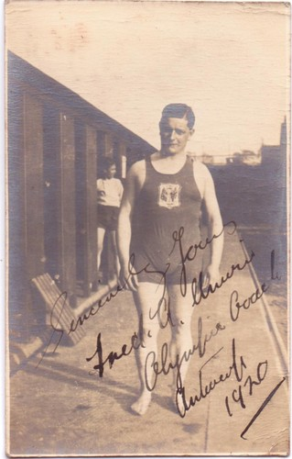
Frederick A Unwin
Sheffield Otter SC
1888-28.5.1865
Winner 1906 1907 1908

